**3. ReactJS – HOL**

**Objectives**

* **Explain React components**

React components are **independent, reusable blocks** of UI built using JavaScript functions or classes. Each component returns a piece of JSX that gets rendered to the DOM.

* **Identify the differences between components and JavaScript functions**

| **Feature** | **JavaScript Function** | **React Component** |
| --- | --- | --- |
| Purpose | Performs logic or computation | Returns UI (JSX) for rendering |
| Return Type | Returns any data type | Must return JSX or null |
| Naming Convention | Can be any name | Must start with a capital letter |
| JSX Usage | Not applicable | JSX used inside return |

* **Identify the types of components**

1. Class Component
2. Function Component

* **Explain Class Component**

1. Uses ES6 class syntax
2. Inherits from **React.Component**
3. Has lifecycle methods like **constructor(),** **componentDidMount()**
4. Uses **render()** method to return JSX

* **Explain Function Component**

1. A simpler component declared using a function
2. Can use React Hooks for state and side effects
3. Cleaner and easier for most use cases

* **Define Component Constructor**

A **constructor** in a class component is used to initialize state and bind methods.

constructor(props) {

super(props);

this.state = {};

}

* **Define render() function**

1. A method inside class components that **returns JSX** (UI code).
2. Must be present in every class component.

**EXERCISE – 2:** Creation of a Score Calculator App

Step 1: Open **VS Code**

Step 2: Create a New React App

**npx create-react-app scorecalculatorapp**

step 3: Navigate into the project folder

**cd scorecalculatorapp**

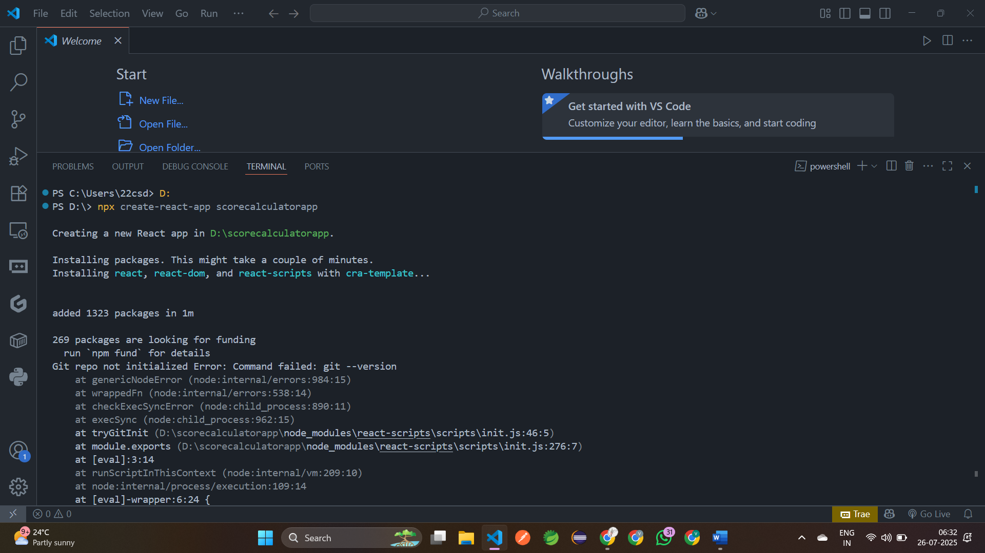

step 4: Create Components folder inside src

**mkdir src/Components**

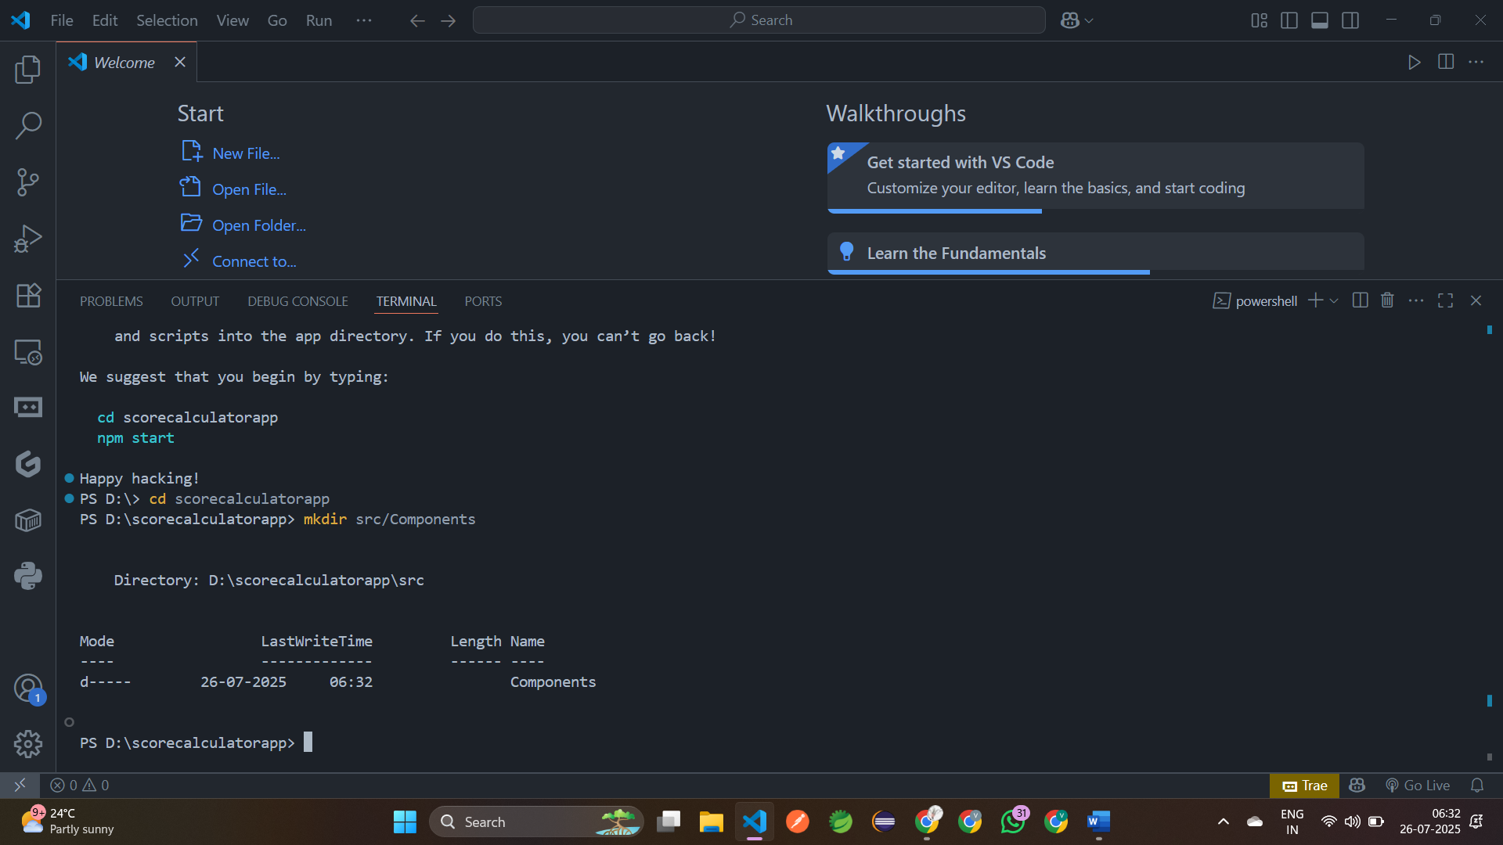

step 5: Inside **src/Components**, create **CalculateScore.js**

import React from "react";  
 import "../Stylesheets/mystyle.css"  
 const percentageToDecimal=(decimal)=>{  
     return (decimal.toFixed(2)+'%')  
 }  
 const calcScore=(total,goal)=>{  
     return percentageToDecimal(total/goal)  
 }  
 export const CalculateScore=({Name,School,total,goal})=>(  
     <div className="formatstyle">  
         <h1><font color="Brown">Student Details:</font></h1>  
         <div className="Name">  
             <b><span>Name: </span></b>  
             <span>{Name}</span>  
         </div>  
         <div className="School">  
             <b><span>School: </span></b>  
             <span>{School}</span>  
         </div>  
         <div className="Total">  
             <b><span>Total: </span></b>  
             <span>{total}</span>  
             <span>Marks</span>  
         </div>  
         <div className="Score">  
             <b>Score: </b>  
             <span>  
                 {calcScore(  
                     total,goal  
                 )}  
             </span>  
         </div>  
     </div>  
 )

step 6: Create a Folder named **Stylesheets** and add a file named **“mystyle.css”**

.Name{  
     font-weight: 300;  
     color: blue;  
 }  
 .School{  
     color: crimson;  
 }  
 .Total{  
     color: darkmagenta;  
 }  
 .formatstyle{  
     text-align: center;  
     font-size: large;  
 }  
 .Score{  
     color: forestgreen;  
 }

step 7: Open **src/App.js** and modify it

import './App.css';  
 import { CalculateScore } from './Components/CalculateScore';  
 function App() {  
   return (  
     <div className='App'>  
 <CalculateScore Name={"Vikasita"}  
       School={"Sri Krishna"}  
       total={580}  
       goal={3}/>  
     </div>  
   );  
 }  
 export default App;

step 8: Run the App using **npm start**

Url: <http://localhost:3000>

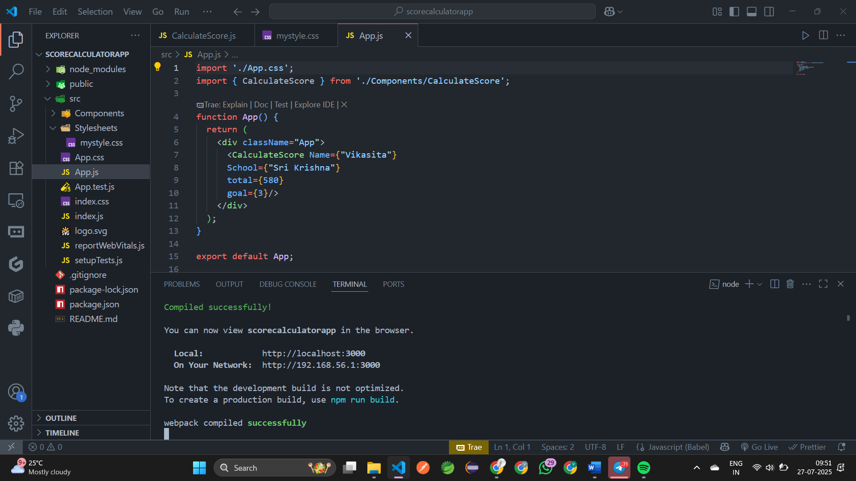

**Output:**

